Q2
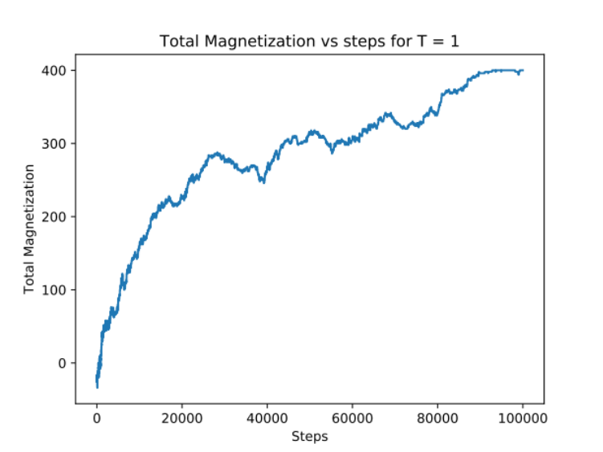
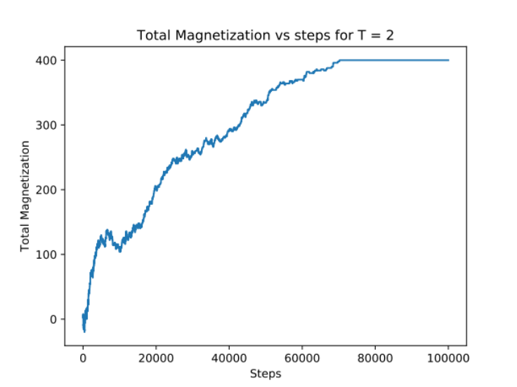
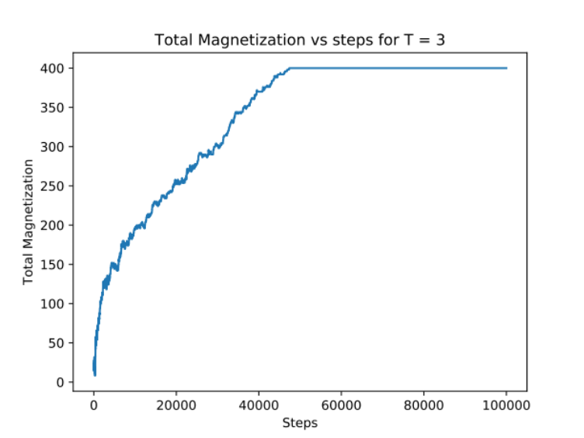

By comparing the total magnetization from different temperature, we can see that all the graphs are approaching 400, which is when all the spins are 1. The only difference is the steps they take to reach 400. T = 1 takes around 90000 steps, T = 2 takes around 70000 steps and T = 3 takes around 50000 steps.

